1. **What is conditional formatting?**

Answer: Conditional Formatting allows you to format a cell based on the value in it. For example, if you want to highlight all the cells where the value in less than 30 with a red colour, you can do that with Conditional Formatting.

1. **What is a Combo Chart?**

Answer: A combo chart is a combination of line and columns together in single chart. It comprises of two data point, for example the total sales value in columns and % of profit earned in the line format. The Axis can be switched to Primary and Secondary based on the objective. This make the chart more decipherable for conclusions.

1. **What is the best way to represent performance of 4 zones in a single year?**

Answer: Since the data is only for single numerical variable, ‘performance’ the best is to use a Pie chart. This will be a clear representation of which zone’s performance. Remember, Pie chart will automatically convert ‘numbers’ into ‘percentage’. Plus pie chart should not be used to represent for more than 5 different zones.

1. **You have data of total review & % of profit we made for the last 4 months. How will you represent this data?**

Answer: I will choose to present this in a combo chart. Primary data point will be the total revenue the company made as column and a line chart go show the profit % but as a secondary access as the prime will have integers and the profit is in decimals.

1. **You are being given a table of sales done by executives, I want you to highlight the top 5 executives with highest sales. What will you do?**

Answer: A built in function is available which can highlight a series of numbers are on top or bottom. To get to this we will have to use the conditional format, go to ribbon>Home> under styles tab> Conditional Format>Top Bottom Rules>Top 10 items hit enter post selecting the range. The to 10 cells will be auto highlighted

1. How do you create a heatmap in a table, such as this one, which is responsive to the values?  
   [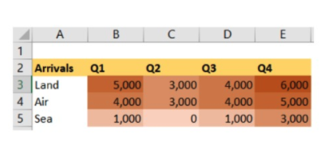](https://github.com/Ebazhanov/linkedin-skill-assessments-quizzes/blob/main/microsoft-excel/images/Q99.png?raw=png)
   1. map chart
   2. **color scales (within conditional formatting)**
   3. manual highlighting
   4. data bars (within conditional formatting)
2. What ribbon command on the Home tab can you use to change a cell's fill color automatically, based on the value of the cell?
   1. **Conditional Formatting**
   2. Format
   3. Cell Styles
   4. Fill
3. How do you remove only the conditional formatting from a cell and leave all other formatting intact?
   1. This is not possible-you can remove only all formatting from a cell.
   2. **Select the cell. On the Home tab, click Conditional Formatting > Clear Rules > Clear Rules from Selected Cells.**
   3. Right-click the cell and select Delete Conditional Formatting.
   4. Right-click the cell and select Remove Conditional Formatting.
4. How can you see the data in column E?

[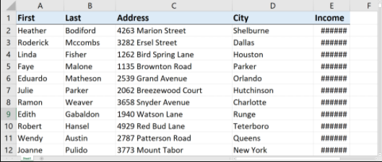](https://github.com/Ebazhanov/linkedin-skill-assessments-quizzes/blob/main/microsoft-excel/images/Q112.png?raw=png)

* 1. Close the workbook without saving and reopen it.
  2. Turn off conditional formatting.
  3. On the Home tab of the ribbon, select Fit to Column.
  4. **Expand the width of its column.**

1. What Excel feature can you use to automatically format cells that are greater than a specified value with designated fill and text colors?
   1. Flash Fill
   2. **Conditional Formatting**
   3. Format as Table
   4. Theme Colors
2. Where can you find the option to set Conditional Formatting rules?
   1. a) Under the Insert tab on the Ribbon in the Formatting group.
   2. b) Under the Page Layout tab on the Ribbon in the Styles group.
   3. **c) Under the Home tab on the Ribbon in the Styles group.**
   4. d) Under the Formulas tab on the Ribbon in the Formatting group.
3. Which of the following formatting options can you set for Conditional Formatting rules?
   1. a) Light Red Fill With Dark Red Text, Yellow Fill With Dark Yellow Text and Green Fill With Dark Green Text.
   2. b) Light Red Fill With Dark Red Text.
   3. c) Light Red Fill, Light Yellow Fill and Light Green Fill.
   4. **d) You can apply any of the formatting detailed in the options above as well as number, border, shading and font formatting.**
4. Top/Bottom Rules allow you to apply conditional formatting to cells that fall within the top or bottom numbers or percentile. How many items will it allow you to include in the rule?
   1. a) The top or bottom 10 items or top or bottom 10% only.
   2. b) The top 10 items and top 10% only.
   3. c) The top or bottom 100 items only.
   4. **d) Any logical number of items or percentages in top or bottom value frames.**
5. How do you change the range of cells that a Conditional Formatting rule applies to?
   1. a) You cannot change the range, you have to clear the rule first and then reapply it.
   2. **b) In the Conditional Formatting Rules Manager dialogue box, edit the cell range for the rule in the Applies To section.**
   3. c) Select the cell range and reapply the rule. This will automatically delete the previous rule and create a new one.
   4. d) Right click the cell range and select Update Conditional Formatting Rule from the menu list.
6. Immediately after applying a conditional formatting rule, you realize it is a mistake. How do you fix it? Choose the best answer:
   1. **a) You have to clear the rule you created by going to the Conditional Formatting Rules Manager dialogue box and deleting the rule.**
   2. b) You have to clear all rules that have been applied to the worksheet or selected range, by clicking on the Clear Rules button.
   3. c) You can simply press the Undo button or use the shortcut Ctrl+Z to undo the last rule created.
   4. d) You can right click the area where the conditional formatting rule has been applied and select Clear Rule from the menu list.
7. The Conditional Formatting function in Excel allows you to:
   1. a) Automatically apply formatting based on specific rules or conditions being met.
   2. b) Automatically apply highlighting to selected cell ranges based on specific rules or conditions being met.
   3. c) Automatically change the font of selected cell ranges based on specific rules or conditions being met.
   4. **d) All of the options listed above are correct**
8. Is it possible to Conditionally format whole row within Excel Conditional Formatting option?
   1. **True**
   2. False